Chapter 6, Solution 22.

Combining the capacitors in parallel, we obtain the equivalent circuit shown below:
30 μF
40 μF
60 μF
20 μF
a
b

Combining the capacitors in series gives 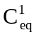, where
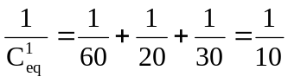 = 10μF

Thus
C_{eq} = 10 + 40 = 50 μF

